Care for Personal Needs
- Can blow nose, cover sneeze
- Can wash own hands
- Can snap, button, zipper or belt own pants
- Can take off and put on coat
- Can tie shoes
- Recognizes own possessions: Jacket, Lunchbox, etc.
- Can eat unassisted
- Can use silverware
- Will put away toys when asked
Social
- Will listen to an adult and do as told
- Can cooperate with other children
- Can play with other children without hitting or biting
- Can sit for short periods
- Can follow a rule
- Understands and follow oral directions
Health
- Is Independent in using the toilet
- Has had a health check-up and required immunizations
- Receives medical care when sick
- Eats at regular times each day
- Gets eight or more hours of sleep at night
- Can run, jump, climb, swing, and use balls.
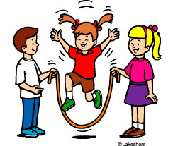

Intellectual
- Shows an interest in books and reading
- Holds book and turns pages correctly
- Know some songs, rhymes
- Participates in rhyming games
- Identifies labels and signs in the environment
- Pretends to read and right
- Knows first and last name
- Can right name using Capital and lowercase letters (Adam not ADAM)
- Can count to 10
- Can identify numbers
- Can identify shapes
- Can identify colors
- Understands position and direction words
- Can tell and retell familiar stories
- Can tell about an experience
- Can communicate personal needs
- Has a variety of experiences such as library, park, zoo, grocery store, post office
- Can use crayons, pencil, scissors, and glue
- Expresses ideas with drawing
- Is willing to try a task

